Surrealism
What is Surrealism?
Surrealism is an invented word –“sur” means beyond or farther than, so “surreal” means to go beyond real. It was named this because surrealist art derives much of its meaning from the theories of Dr. Sigmund Freud and the unconscious.
Surrealism tried to meld the conscious and the unconscious, the world of dreams and fantasy along with reality so that the line between these ideas was completely blurred. Much of Surrealistic art portrays alternate realities; some created by accident, some using the unconventional realities of blind feeling and impulse. Some of the art of this time is quite cruel and violent as well as very beautiful. The artists, like the Dada artists before them, wanted to shock their viewers with the unexpected and make people think in new ways.
The surrealists admired the artwork of the insane for its freedom of expression, as well as artworks created by children.

What is the difference between the conscious and unconscious mind?
Subconscious Mind
Your subconscious mind is responsible for your emotions, thoughts, ideas, habits, outlooks, beliefs and how you choose to make some kind of meaning to your experiences in life. You do not experience life, you run everything through a subconscious system of internal filters, which change the information you notice.
Conscious Mind
The conscious part of your brain has some amazing qualities like deduction, reasoning, logic, short-term memory, and a notion of time and space. Most importantly, it is the only part of your mind that has the ability to accept or reject information, or ideas you choose to place before it.

Salvador Dali is without doubt, the most famous member of the surrealist group. His painting, The Persistence of Memory, almost stands alone as a symbol of the movement. The melted clocks represent the strange warping of time which occurs when we enter the dream state.

Max Ernst, Giorgio de Chirico, Man Ray, Joan Miro, Yves Tanguay and Rene Magritte.
See back for some samples

Salvador Dali
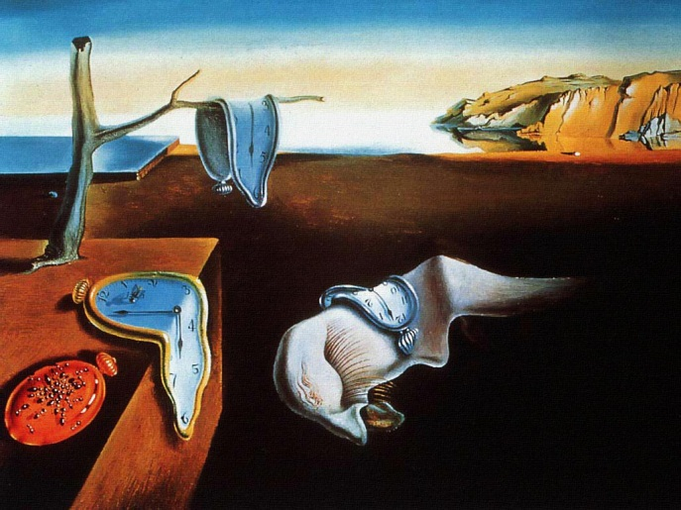
Max Ernst
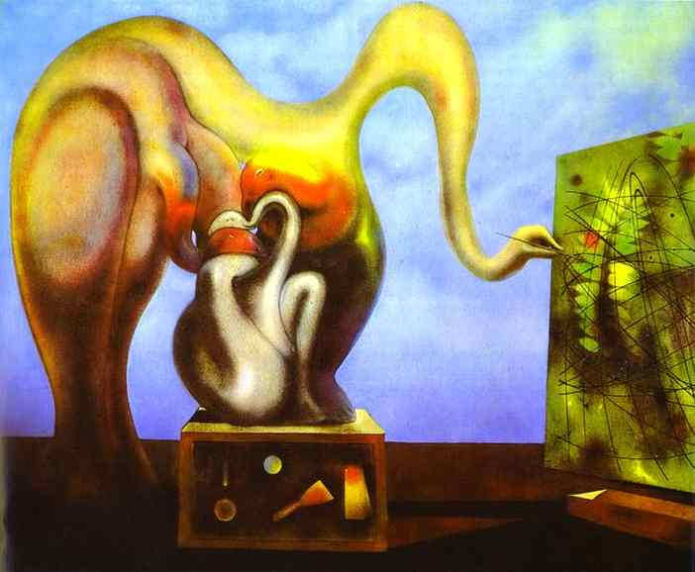
Rene Magritte
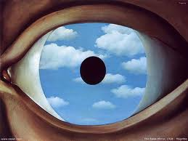
Joan Miro
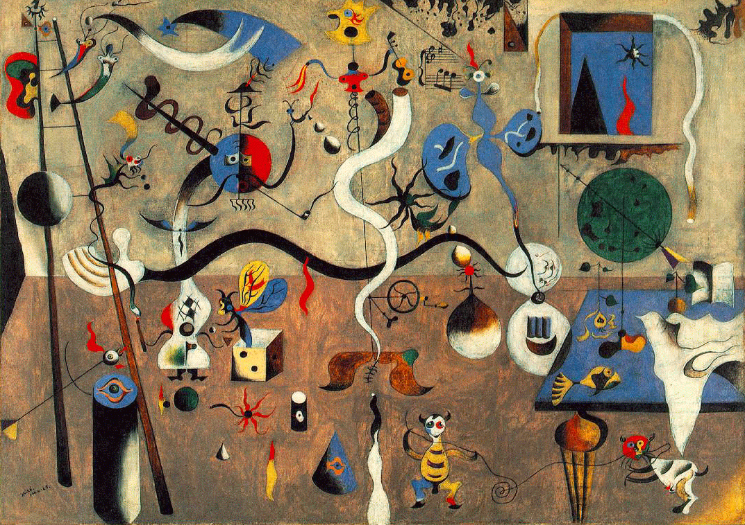
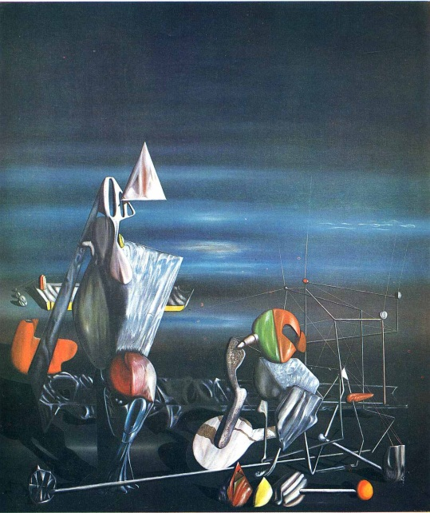
Yves Tanguy

Preposterous Crosslink Creatures
Create an impossible hybrid ‘creature’ that is part organic, part inorganic. Select two words, one from each section (organic/inorganic) and create a brand new ‘creature’ that is crossbred between the two selected words. Be creative! Sketch some ideas for several different combinations and select 1 hybrid creature to create a final sketch of.

Organic
Aardvark
Alligator
Alpaca
Anteater
Antelope
Armadillo
Baboon
Badger
Bat
Bee
Bear
Beaver
Bison
Boar
Buffalo
Bull
Bunny
Camel
Canary
Cat
Chameleon
Cheetah
Chimpanzee
Chinchilla
Chipmunk
Cow
Coyote
Crocodile
Crow

Deer
Dog
Dolphin
Donkey
Elephant
Elk
Ferret
Fish
Fox
Frog
Fish
Gazelle
Giraffe
Goat
Gopher
Gorilla
Hamster
Hedgehog
Hippopotamus
Horse
Hyena
Iguana
Kangaroo
Koala
Lamb
Leopard
Lion
Lizard
Llama
Monkey

Moose
Mouse
Otter
Ostrich
Octopus
Panda
Pig
Piranha
Platypus
Polar bear
Porcupine
Rabbit
Raccoon
Ram
Rat
Rhinoceros
Sheep
Skunk
Sloth
Spider
Snake
Squirrel
Tiger
Turtle
Tarantula
Walrus
Whale
Wolf
Zebra

Turn over for inorganic
Inorganic
Airplane
Baseball
Broom
Button
Buckle
Bell
Bucket
Boot
Bathtub
Brush
Balloon
Bike
Candle
Computer
Camera
Clothes hanger
Car
Cabinets
Credit card
Clock
Cards
Chair
Chain-link Fence
CDs
Drums
Envelope
Flag
Fan
Fork
Samples:

Football
Faucet
Glasses
Garbage Can
Guitar
Golf ball
Helmet
Hammer
Headphones
Iron
IPod/IPhone
Jar
Keys
Lamp
Light bulb
Lock
Mirror
Microwave
Mug
Mailbox
Pliers
Pencil
Plug
Paintbrush
Paint tubes
Pencil Sharpener
Phone
Purse
Pots and Pans
Paperclip

Road Signs
Remote
Refrigerator
Ruler
Saw
Scissors
Screwdriver
Spoon
Soda Can
Seat Belt
Sponge
Spring
Stapler
Spatula
Shovel
Steering Wheel
Stool
Sunglasses
Suitcase
Table
Tire
Toothbrush
Toilet
Television
Vase
Watch
Wallet
Yarn
Zipper

